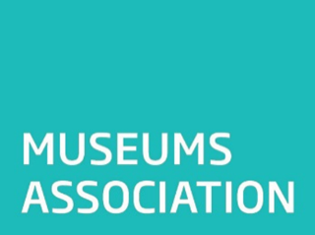
Guidance Notes: Running a Collections 2030 Discussion Session
The Museums Association (MA) has launched Collections 2030, a major new research project that seeks to understand the current state of museum collections in the UK, and – in collaboration with the sector – identify how to make the most of museum collections over the course of the next decade.
The MA has published a discussion paper and a series of research questions and is looking for responses from across the sector.

As well as individual responses, the MA is looking for responses that have been collectively reached by groups of museum professionals or those who work with them. You can feed in effectively by running a session that looks at the research, promotes discussion of the questions and develops responses.

Here are some suggestions for how to go about this:

- Find a forum where you meet regularly with colleagues, a departmental meeting, a meet up of Emerging Museum professionals or AMA support group for example. Ask if you can theme a session around Collections 2030 – it can be a useful tool for focusing future working or professional development.

- Set aside enough time to allow debate around each section. We’d suggest a minimum 60 minutes but if you are able to allow longer then do. Some questions to take longer to debate than others.

- Before the meet up forward the discussion paper to attendees to read in advance. Ask colleagues to think specifically about it from their own experiences of museum collections work. We want wide range of experiences and job roles to participate. It’s not just for Curators and Collection Mangers – Collections 2030 is for everyone in the sector.

- Before the meet up familiarise yourself with the research questions so that if a debate is heading towards answering a different question you can put a pin in it for later. Nominate a note taker to record all the key points and responses and don’t expect a clear answer to each question to emerge straight away. Ensure they are familiar with the questions too.

- During the session keep the debate on track. It can be useful to establish ground rules to share and create expectations resulting in greater participation. If one individual is dominating discussions you may need to politely intervene and encourage others to contribute as well. This is a useful exercise in chairing and tips on how to do run successful meetings can be found here: https://www.scoro.com/blog/tips-for-effective-meeting-management/ or https://www.forbes.com/sites/forbesleadershipforum/2014/02/05/seven-steps-to-running-the-most-effective-meeting-possible/#94628547a613

- After the meeting collate the notes taken into responses – ensure they reflect the collective views of the group. There’s a 250 word limit on responses which allows for more complex views to be expressed. You could also send your answers to the group before filling in the online response so that those that participated have an opportunity to approve what they have discussed before submission.

- Submit the responses online here https://r1.dotmailer-surveys.com/c72vbx8a-a93awz3e and encourage participants to complete responses individually too.

Collections 2030 is a consultation process – we want you to have your say.

