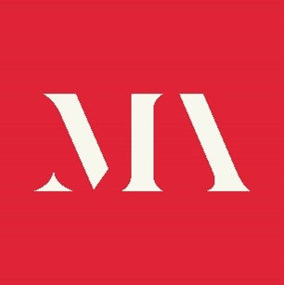

Application Form

Role applied for:

Personal Details

Name

Address

Email address

Contact Telephone

Professional biography
Please enter a brief professional biography below (no more than 100 words).

Personal Statement
Please enter your personal statement below (maximum 300 words) outlining the values, qualities and experience you would bring to the Ethics Committee and your understanding and commitment to MA policies such as Museums Change Lives, the Code of Ethics for Museums and the Supporting Decolonisation in Museums Guidance.

Are you related to any member of the staff or board of the Museums Association?

Declaration
The information I have given in this application form is correct.
Signature Date

Data privacy
We will treat all personal information in line with current data protection legislation and our data protection policy.

Please return the completed form to Charlotte Eyles charlotte.eyles@museumsassociation.org

