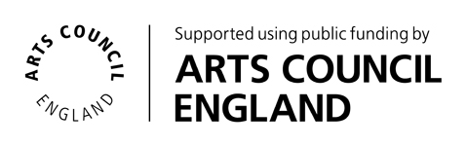
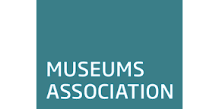

Mentoring for All – inclusive mentoring for the sector

Mentor Application Form

Please complete the form below with reference to the Application Pack. Return it by email to Tamsin Russell, professional development officer, Museums Association, Tamsin@museumsassociation.org.
The closing date for applications is 10am on Monday 24 April 2017.

Your details

First name
Surname
Home or work address
Telephone number
Mobile number
Email

Your experience

Place of work
Position
Status: Paid member of staff, volunteer and/or consultant/ freelancer?

In years, how much experience do you have in the museum or cultural heritage sector?

5 to 10 years
10 to 15 years
More than 15 years

Please indicate which type(s) of organisation you have worked in.

National Trust or National Trust for Scotland
Historic Environment Scotland
English Heritage
Other historic property/house
Independent museum
Local Authority museum or service
National museum (DCMS grant)
Regimental/military museum
University museum
Other
If other, please specify: ________________________________________________

Please describe your key responsibilities, interests and experience within the sector (300–400 words).

Your interest in Mentoring for All

Please tell us why you want to be a mentor; what do you hope to contribute, develop or gain by participating (max. 400 words)?

It is not essential to have prior mentoring experience; however, where applicable, please describe your experiences as a mentor, outlining your style and approach to mentoring (max. 300 words).

MENTOR DECLARATION

If selected, I will work within the principles and practices of Mentoring for All, actively participate in the mentoring process, and contribute to the evaluation of the pilot.

I am able attend a workshop on 16 May 2017 in Birmingham.

Name_______________________________________ Date_______________

