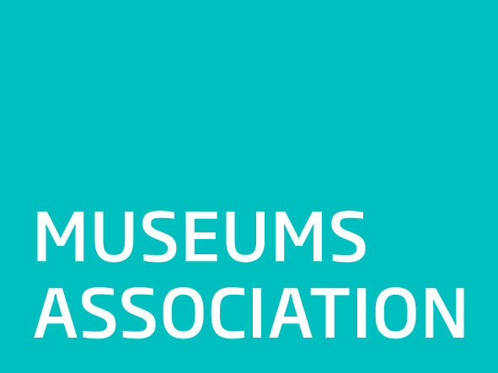

Museums Association Equality and diversity monitoring form
In accordance with the Museums Association Equal Opportunities and Diversity Policy, the Museums Association will provide equal opportunities to all candidates. This includes not discriminating under the Equality Act 2010, and building an accurate picture of the make-up of the workforce in encouraging equality and diversity. In order to enable us to ensure our compliance with this policy, we would be grateful if you would complete the following tables for monitoring purposes. We will treat information confidentially and it will not be used as part of the shortlisting process.
Gender: |  | Male: ☐ Female: ☐ Prefer not to say: ☐
Are you married or in a civil partnership? |  |  |  |  | Yes: ☐ No: ☐ Prefer not to say: ☐
Age: | 16-24: ☐ 25-29: ☐ 16-24: ☐ 25-29: ☐ 30-34: ☐ 35-39: ☐ 40-44: ☐ 49-49: ☐ 50-54: ☐ 55-59: ☐ 60-64: ☐ 65+: ☐ Prefer not to say: ☐
What is your ethnicity? Ethnic origin is not about nationality, place of birth or citizenship. It is about the group to which you perceive you belong. (Please tick appropriate box)
White
English: ☐ |  |  |  | Welsh: ☐ |  |  | Scottish: ☐ | Northern Irish: ☐
British: ☐ |  |  |  | Gypsy or Irish Traveller: ☐ |  |  | Prefer not to say: ☐
Any other white background, please write in:
Mixed/multiple ethnic groups
White & Black Caribbean: ☐ |  |  |  | White & Black African: ☐ |  |  | White & Asian:☐ | Prefer not to say: ☐
Any other mixed background, please write in:
Asian/Asian British
Indian: ☐ |  |  |  | Pakistani: ☐ |  |  | Bangladeshi: ☐ | Chinese: ☐
Prefer not to say: ☐ |  |  |  | Any other Asian background, please write in:
Black/African/Caribbean/Black British
African: ☐ |  |  |  | Caribbean: ☐ |  |  | Prefer not to say: ☐
Any other Black/African/Caribbean background, please write in:
Other ethnic group
Arab: ☐ |  |  |  | Prefer not to say: ☐ |  |  | Any other ethnic group, please write in:
What is your religion or belief? (Please tick appropriate box)
No religion or belief: ☐ |  |  |  | Buddhism: ☐ |  |  | Christianity: ☐ | Hindu: ☐
Jewish: ☐ |  |  |  | Muslim: ☐ |  |  | Sikh: ☐ | Prefer not to say: ☐
If other religion or belief, please write in: ☐
Do you consider yourself to have a disability or health condition? (Please tick the appropriate box) |  |  |  |  |  | Yes: ☐ No: ☐ Prefer not to say: ☐  What is the effect or impact of your disability or health condition on your ability to give your best at work? Please write in here:  The information in this form is for monitoring purposes only. If you believe you need a ‘reasonable adjustment’, then please discuss this with Pauline Mouskis – Pauline@museumsassociation.org / 0207 566 7800
What is your sexual orientation: |  |  | Heterosexual: ☐ Gay woman/lesbian: ☐ Gay man: ☐ Bisexual: ☐ Prefer not to say: ☐  If other, please write in:

